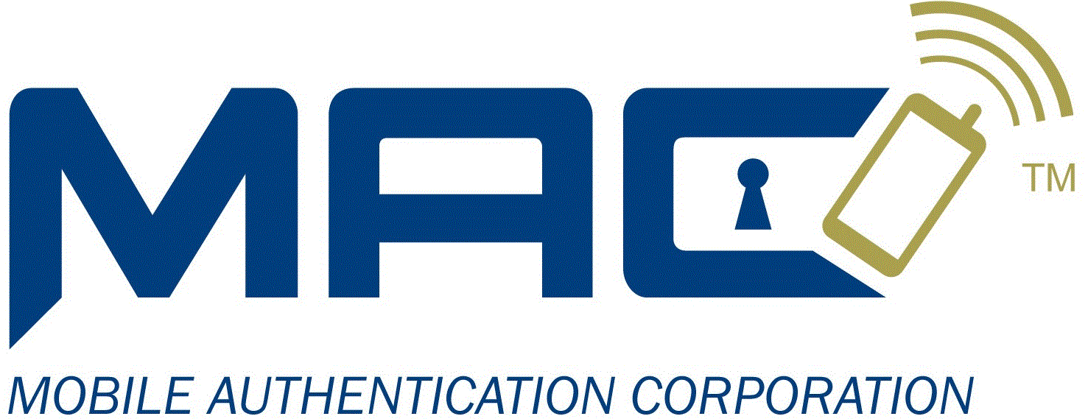

|  |
| --- |
|  |
| Mobile Authentication Corporation |
| OTP Services API, Version 1.4 |

|  |
| --- |
|  |

# Introduction

This document defines the API for the Web Services for the MAC OTP System (“System”). The System is comprised of several Web Services (“Services”) that provide the functionality needed to send and verify One-Time Passwords as text messages using the SMS network. The API also supports sending regular text messages (containing no OTP). As a configuration option, the System can send messages via the voice network. The details of the MAC OTP System Registration Service APIs are not included in this document.

Overview

Contained in this document are brief descriptions of the HTTP/HTTPS methods for sending requests to the Services, the responses, the message formats, and the client requirements. The document also contains JavaScript/JQuery examples of the functions which create and issue the calls, as well as, process the responses.

## System diagrams

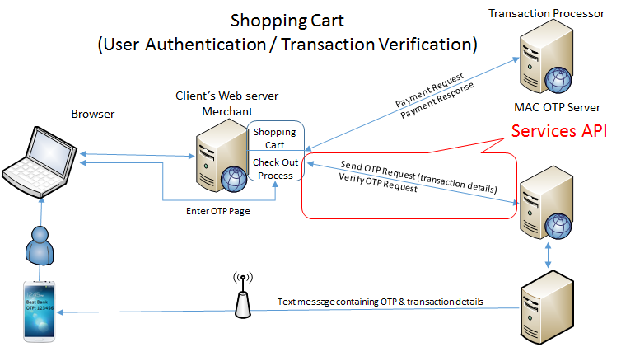

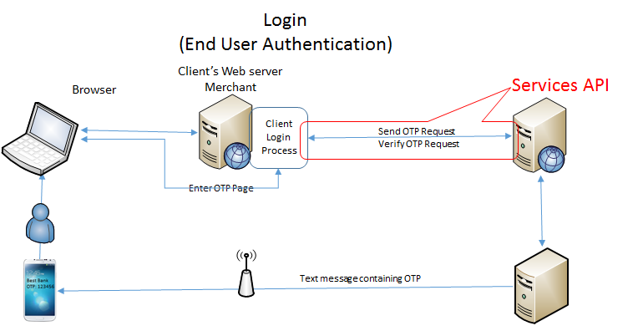

Client Requirements

The MAC system requires every client to be registered with the system. When registered, the client will be issued a ***Client ID***. Every request issued to one of the Services must contain a valid Client Id. Optionally, the system supports the concept of a **Group.**  A group is a collection of one or more clients.

**Note**: Examples in this document do not have Group Ids.

## End Users

In the context of the MAC OTP System and this document “End Users” are the customers of the Clients. The end users are the people that receive the OTP messages on their SMS enabled devices. The System expects end user to be controlled by the client or be registered with the System. In the “Client Controlled” API calls it is the responsibly of the client to insure that the end user’s phone number and email address are valid. The System only checks the client id and the format of the phone number and email address. In the “Registered” API calls the end user must be registered before the OTP requests are processed by the System. The phone number and the email address are maintain in the System database. The Service API requires that the caller hash, using MD5 hash algorithm the unique user identification and user last name in order to create a unique ”UserId”. The System checks for a valid UserId before processing an OTP request.

## OTP Services

There are two Services that support the One-Time Password and send Message functionality, the RequestOTP Service and the VerifyOTP Service. Each has their own URL. The base URL (where the Services are running) combined with the Service URL make up the HTTP address.

RequestOTP: Otp/RequestOTP.asmx/WsRequestOtp

VerifyOTP: Otp/ValidateOTP.asmx/WsValidateOtp

## Service API Requests

Services support the HTTP/HTTPS Post method where the data contains the request details. Depending on the implementation, the data is either converted to hexadecimal strings or encrypted (recommended when using HTTP) before sending as data to the request, this avoids special character conflicts.

## Request Format Details

The parameters for a request are assembled in an ASCII string as a key value pairs with each key/value separated by the pipe character “|” and the keys are separated from the values by the colon character “:”. Some values, such as the Transaction details may contain special character that would cause problems in the request process. These values must be converted to a hexadecimal string before it is added to the request parameters. (See the coding examples section for details).

**Note**: The following example is for a “Client Managed End User” request. The client is responsible for supplying the end user’s phone number and email address. MAC’s OTP system does not maintain or verify the end user information. For details of a “Registered End User” request refer to the coding examples.

* Example of JavaScript function call

function RequestOtpClientManagedEndUser(

pClientId, // Client Id (required)

pEndUserPhoneNumber, // End user’s phone number (required, format is validated)

pEndUserEmail, // End user’s email address(required, format is validated)

pEndUserIp, // End user’s machine’s IP address (optional)

pTransactionType, // OTP Message type (optional, default is 0)

pTransactionDetails, // Transaction Details (optional, included in OTP message)

pCallbackFunction)

* Example before hexadecimal encoding:

**Note**: Key value pairs with keys in red and values in blue (key value separator is in black).

Request:SendOtp|CID:5351674c74846919ec735074|PhoneNumber:4802684076|EmailAddress:tdavis@mobileauthcorp.com|EndUserIpAddress:192.168.168.1|TrxType:2|TrxDetails:4861742031372e39397c4a61636b657420243135302e39387c546f74616c20243136382e3937|API:TNS

Where:

1. The request (required): Request:SendOtp

**Note**: In this example send OTP to a Client managed end user.

1. Client Id (required): <CID:5351674c74846919ec735074>
2. End user’s mobile phone number (required): PhoneNumber:4802684076
3. End user’s email address (required): EmailAddress:tdavis@mobileauthcorp.com
4. End user’s machine IP address (optional): EndUserIpAddress:192.168.168.1
5. Transaction type (optional default is 0 ‘OTP’): TrxType:2
6. Transaction details (optional, default is no details in OTP message): TrxDetails:4861742031372e39397c4a61636b657420243135302e39387c546f74616c20243136382e3937

**Note 1**: Transaction details (the value) is hexadecimal encoding to avoid issues with special character

**Note 2**: see transaction details encoding for formatting details.

1. Who is making the request (optional, used for resolving errors): API:TNS

* Example after hexadecimal encoding (complete data packet):

Data=

* Break down of components:

Http post header: Data=

Hexadecimal encoded indicator: 99

Length of client id: 24

Client id (as issued by MAC): 5351674C74846919EC735074

Request data (Hexadecimal encoded): 

### Transaction Details Format and Encoding

The transaction details could contain new lines and characters that can’t be sent as ASCII characters.

1. The new lines in the transaction details and in the send message text must be replaced by the pipe character “|”. The massage assembly logic replaces the pipe character with the appropriate new line sequence for the message delivery channel.
2. The transaction details and the send message body are hexadecimal encoded.

* Example before encoding:

Hat $17.99|Jacket $150.98|Shirt $33.98|Total $202.95

**Note:** The example will be displayed in the OTP message as 4 lines.

## Response Formats Details

All the OTP Services responses are formatted in XML. Responses contain a Reply node if successful and an Error node if unsuccessful.

* Example of response to successful request:

<?xml version="1.0" encoding="utf-8" ?>

<macResponse>

<calledMethod>WsRequestOtp()</calledMethod>

<Reply>

<Action>Sent</Action>

<RequestId>5351a84074846919d8f97e17</RequestId>

<DeliveryMethod>SMS</DeliveryMethod>

</Reply>

</macResponse>

**Note:** In the example above the response is for a “SendOTP” request. The RequestId is used as the correlation number and must be returned in the VerifyOTP request.

* Example of response to unsuccessful request:

<?xml version="1.0" encoding="utf-8" ?>

<macResponse>

<Error>Invalid Request Id</Error>

</macResponse>

# Detail Coding Examples

The following examples are provided as JavaScript/JQuery source and intended to give the integrator the details need to implement the various OTP Service calls.

//-------------- One Time Password service calls -----------------------------------

//-------- Send OTP Message to a client managed end user ---------------------------

function RequestOtpClientManagedEndUser(

pClientId, // Client Id (required)

pGroupId, // Group Id (optional)

pEndUserPhoneNumber, // End user’s phone number (required, format is validated)

pEndUserEmail, // End user’s email address(required, format is validated)

pEndUserIp, // End user’s machine’s IP address (optional)

pTransactionType, // OTP Message type (optional, default is 0)

pTransactionDetails, // Transaction Details (optional, included in OTP message)

pAdPass, // Ad Pass Option (optional, set opt-out for this OTP Message)

pCallbackFunction)

{

var requestData = "Request:SendOtp"; //Command to service

if (pClientId.Length == 0) //Client Id as issued by MAC

return ("Client ID required!");

requestData += "|CID:" + pClientId;

if (pGroupId != 0) // Optional if client request is restricted to a group

requestData += "|GroupId:" + pGroupId;

if (pEndUserPhoneNumber.Length == 0)

return ("End User's Phone Number required!");

requestData += "|PhoneNumber:" + pEndUserPhoneNumber;

if (pEndUserEmail.Length == 0)

return ("End User email address required!");

requestData += "|EmailAddress:" + pEndUserEmail;

if (pEndUserIp.Length != 0)

requestData += "|EndUserIpAddress:" + pEndUserIp;

if (pLabelIndex.Length != 0) {

requestData += "|TrxType:" + pLabelIndex;

}

if (pTransactionDetails.Length != 0)

requestData += "|TrxDetails:" + StringToHex(pTransactionDetails);

if (pAdPass != 0) // Optional Client is setting Ad Pass option

requestData += "|APOpt:" + pAdPass; // ‘APEnable’ send Ad, ‘APDisable’ do not send Ad.

requestData += "|API:TNS"; // who is calling service

// 99 indicates the data is converted to a hex string (not encrypted)

var data = "Data=99" + pClientId.length.toString() + pClientId.toUpperCase() +

StringToHex(requestData);

$.post(GetMACServicesBaseURL() + RequestOtpWebService, data, pCallbackFunction);

return "";

}

//-------- Send OTP Message to a Registered end user ---------------------------

function RequestOtpRegisteredEndUser(

pClientId, // Client Id (required)

pGroupId, // Group Id (optional)

pEndUserUniqueIdentifier, // End user’s unique identifier, as registered (required)

pEndUserLastName, // End user’s last name, as registered (required)

pEndUserIp, // End user’s machine’s IP address (optional)

pTransactionType, // OTP Message type (optional, default is 0)

pTransactionDetails, // Transaction Details (optional, included in OTP message)

pCallbackFunction)

{

var requestData = "Request:SendOtp"; //Command to service

if (pClientId.Length == 0) //Client Id as issued by MAC

return ("Client Id required!");

requestData += "|CID:" + pClientId;

if (pGroupId != 0) // Optional if client request is restricted to a group

requestData += "|GroupId:" + pGroupId;

if (pEndUserUniqueIdentifier.length == 0)

return ("End User UID required!");

if (pEndUserLastName.length == 0)

return ("End User Last Name required!");

// Unique UserId: Must match the UserId used in the registration process

requestData += "|UserId:" + HashUserId(pEndUserLastName, pEndUserUniqueIdentifier)

if (pEndUserIp.Length != 0)

requestData += "|EndUserIpAddress:" + pEndUserIp;

if (pLabelIndex.Length != 0)

requestData += "|TrxType:" + pLabelIndex;

if (pTransactionDetails.Length != 0)

requestData += "|TrxDetails:" + StringToHex(pTransactionDetails);

requestData += "|API:TNS"; // who is calling service

// 99 indicates the data is converted to a hex string (not encrypted)

var data = "Data=99" + pClientId.length.toString() + pClientId.toUpperCase() +

StringToHex(requestData);

$.post(GetMACServicesBaseURL() + RequestOtpWebService, data, pCallbackFunction);

return "";

}

//------------------ Verify an OTP ---------------------------

function VerifyOtp(

pClientId, // Client Id (required, must be the same client Id that made the send OTP request)

pRequestId, // OTP Id (required, returned by the Send OTP request)

pOtp, // OTP (required, entered by the end user)

pCallbackFunction)

{

var requestData = "Request:VerifyOtp"; //Command to service

if (pClientId.Length == 0) //Client Id as issued by MAC

return ("Client ID required!");

requestData += "|CID:" + pClientId;

if (pRequestId.Length == 0)

return ("Request ID required!");

requestData += "|RequestId:" + pRequestId;

if (pOtp.Length == 0)

return ("Otp required!");

requestData += "|Otp:" + pOtp;

requestData += "|API:TNS"; // who is calling service

// 99 indicates the data is converted to a hex string (not encrypted)

var data = "Data=99" + pClientId.length.toString() + pClientId.toUpperCase() +

StringToHex(requestData);

$.post(GetMACServicesBaseURL() + VerifyOtpWebService, data, pCallbackFunction);

return "";

}

//------------------ Cancel an OTP ---------------------------

function CancelOtp(

pClientId, // Client Id (required, must be the same client Id that made the send OTP request)

pRequestId, // OTP Id (required, returned by the Send OTP request)

pCallbackFunction)

{

var requestData = "Request:CancelOtp"; //Command to service

if (pClientId.Length == 0) //Client Id as issued by MAC

return ("Client ID required!");

requestData += "|CID:" + pClientId;

if (pRequestId.Length == 0)

return ("Request ID required!");

requestData += "|RequestId:" + pRequestId;

requestData += "|API:TNS"; // who is calling service

// 99 indicates the data is converted to a hex string (not encrypted)

var data = "Data=99" + pClientId.length.toString() + pClientId.toUpperCase() +

StringToHex(requestData);

$.post(GetMACServicesBaseURL() + RequestOtpWebService, data, pCallbackFunction);

return "";

}

//-------- Resend OTP Message to an end user ---------------------------

function ResendOtp(

pClientId, // Client Id (required, must be the same client Id that made the send OTP request)

pRequestId, // OTP Id (required, returned by the Send OTP request)

pCallbackFunction)

{

var requestData = "Request:ResendOtp"; //Command to service

if (pClientId.Length == 0) //Client Id as issued by MAC

return ("Client ID required!");

requestData += "|CID:" + pClientId;

if (pRequestId.Length == 0)

return ("Request Id required!");

requestData += "|RequestId:" + pRequestId;

requestData += "|API:TNS"; // who is calling service

// 99 indicates the data is converted to a hex string (not encrypted)

var data = "Data=99" + pClientId.length.toString() + pClientId.toUpperCase() +

StringToHex(requestData);

$.post(GetMACServicesBaseURL() + RequestOtpWebService, data, pCallbackFunction);

return "";

}

//------------- Send Text Message service calls -------------------------------------

//-------- Send Text Message to a client managed end user ---------------------------

function SendMessageToClientManagedEndUser(

pClientId, // Client Id (required)

pGroupId, // Group Id (optional)

pEndUserPhoneNumber, // End user’s phone number (required, format is validated)

pEndUserEmail, // End user’s email address(required, format is validated)

pEndUserIp, // End user’s machine’s IP address (optional)

pMessage, // Body of text message (pipe characters for new lines)

pCallbackFunction)

{

var requestData = "Request:SendMessage"; //Command to service

if (pClientId.Length == 0) //Client Id as issued by MAC

return ("Client ID required!");

requestData += "|CID:" + pClientId;

if (pGroupId != 0) // Optional if client request is restricted to a group

requestData += "|GroupId:" + pGroupId;

if (pEndUserPhoneNumber.Length == 0)

return ("End User's Phone Number required!");

requestData += "|PhoneNumber:" + pEndUserPhoneNumber;

if (pEndUserEmail.Length == 0)

return ("End User email address required!");

requestData += "|EmailAddress:" + pEndUserEmail;

if (pEndUserIp.Length != 0)

requestData += "|EndUserIpAddress:" + pEndUserIp;

if (pMessage.Length == 0)

return ("Message required!");

requestData += "|Message:" + StringToHex(pMessage.replace(/\n/g, "|"));

requestData += "|API:TNS"; // who is calling service

// 99 indicates the data is converted to a hex string (not encrypted)

var data = "Data=99" + pClientId.length.toString() + pClientId.toUpperCase() +

StringToHex(requestData);

$.post(GetMACServicesBaseURL() + RequestOtpWebService, data, pCallbackFunction);

return "";

}

//-------- Send Text Message to a registered end user ---------------------------

function SendMessageRegisteredEndUser(

pClientId, // Client Id (required)

pGroupId, // Group Id (optional)

pEndUserUniqueIdentifier, // End user’s unique identifier, as registered (required)

pEndUserLastName, // End user’s last name, as registered (required)

pEndUserIp, // End user’s machine’s IP address (optional)

pMessage, // Body of text message (pipe characters for new lines)

pCallbackFunction)

{

var requestData = "Request:SendMessage"; //Command to service

if (pClientId.Length == 0) //Client Id as issued by MAC

return ("Client ID required!");

requestData += "|CID:" + pClientId;

if (pGroupId != 0) // Optional if client request is restricted to a group

requestData += "|GroupId:" + pGroupId;

if (pEndUserUniqueIdentifier.length == 0)

return ("End User UID required!");

if (pEndUserLastName.length == 0)

return ("End User Last Name required!");

// create unique UserId using md5 hash

requestData += "|UserId:" + HashUserId(pEndUserLastName, pEndUserUniqueIdentifier)

if (pEndUserIp.Length != 0)

requestData += "|EndUserIpAddress:" + pEndUserIp;

if (pMessage.Length == 0)

return ("Message required!");

requestData += "|Message:" + StringToHex(pMessage.replace(/\n/g, "|"));

requestData += "|API:TNS";// who is calling service

// 99 indicates the data is converted to a hex string (not encrypted)

var data = "Data=99" + pClientId.length.toString() + pClientId.toUpperCase() +

StringToHex(requestData);

$.post(GetMACServicesBaseURL() + RequestOtpWebService, data, pCallbackFunction);

return "";

}

//-------- Create UserId using user’s last name and Unique Identifier -------------------

function HashUserId(pLastName, pUniqueIdentifier) {

return hex_md5(pLastName.toLowerCase() + pUniqueIdentifier.toLowerCase()).toUpperCase();

}

# Change History

V1.1 - Original document

V1.2 – Update request parameter names “ToPhone” to “PhoneNumber” and “ToEmail” to “EmailAddress”, add some comments.

V1.3 – update RequestOtpRegisteredEndUser SendMessageRegisteredEndUser examplet where the UserId is created by calling a MD5 hash function, included the HashUserId function to show the end user and the Unique Identifier “UID” are set to lower case before doing the MD5 hash.

V1.4 – Add Ad Pass Opt-out option to RequestOtpClientManagedEndUser example.